**CS1002 - PROGRAMMING IN PYTHON**

**CONTINOUS INTERNAL ASSESSMENT – 2**

**MINI PROJECT – ONE PAGE WRITEUP**

**BARCODE SCANNING BASED ATTENDANCE SYSTEM**

***By***

**Jayashre K – 22011103020**

**B. Tech CSE (specialization in Cyber Security)**

**INTRODUCTION:**

The Barcode Scanning based Attendance System is a python-based project that enables college students and professors to efficiently manage the attendance records of students. This system incorporates the use of ***tkinter*** and ***pyzbar*** python librariesto create a user-friendly attendance system for the batch of Cyber Security students and their faculties. By utilizing a camera to scan the barcode on the student’s identity card and faculties’ identity cards, the system can retrieve their details from an Excel sheet that stores their information. The system then automatically updates the attendance record in Excel, thereby saving time and reducing errors.

**METHODOLOGY:**

1. Importing Modules:

To facilitate the functioning of the project, several modules such as pywin32, opencv, time, pyzbar, tkinter, datetime, and openpyxl are imported. These modules are used for different functionalities in the script and contribute to the seamless execution of the project.

1. Opening Excel files and sheets:

The ***“protected_view_excel”*** function opens Excel files, if the user wants to view attendance records, courses and faculty records or the student records, in protected view, hides sheets that are not currently in use, and protects the sheets with a password. The ***“write_date_to_sub”*** function writes a selected date, by the user, to a specific cell in an Excel sheet.

1. Barcode Scanning:

This system utilizes OpenCV to continuously read and capture frames from the web camera and detect barcodes in those frames through ***“scan_barcodes”*** function. If a new barcode is detected, it is added to the list of barcodes. The *pyzbar* library is then used to decode the barcodes detected by the system.

1. Authenticating users and marking attendance:

* The ***“adding_attendance”*** function scans barcode, reads data from an Excel sheet, and verifies the user’s attendance by checking if their roll number matches the data from the sheet. The ***“add_p”*** function adds the attendance of the verified user to the excel sheet, chosen by the user, of the Excel Workbook.
* From the perspective of faculty members, the system offers the functionality of marking students as "absent" or "present". This feature involves the verification of the registration numbers entered by the faculty against the last two digits of the registration number column. Once the verification process is completed, the system automatically records the attendance status of each student under the designated date selected by the faculty member.

1. Changing the attendance status:

The system also has a feature that enables users to change their attendance system. The ***“absenttopresent”*** function changes the attendance status of a specific user on a particular date for a particular course from “Absent” to “Present” in the excel sheet. Similarly, ***“presenttoabsent”*** function changes the attendance status from “Present” to “Absent”.

*Overall, the methodologies used in the code involve interacting with Excel sheets, scanning barcodes, manipulating data in the pandas Data frame, and using computer vision libraries like OpenCV and pyzbar*.

**CLASSIFIERS:**

The code of this project uses a supervised learning approach to recognize barcodes. The Support Vector Machine (SVM) algorithm are the classifiers to classify the barcode images.

SVMs are particularly useful for accurately classifying different types of barcodes and are used in this project to classify students as present or absent based on the barcode information. The OpenCV library is used to pre-process the images before classification. However, using SVMs requires additional pre-processing steps such as image processing to extract the barcode information.

**DATASETS:**

The code required a dataset of barcode images to train the classifiers. The project utilized an Excel workbook as a database. Here are the main datasets were used:

1. ***Student data*** – that includes information about the students, such as their names. Roll number and other relevant information. This data is used to create unique student barcodes that can be scanned to track attendance.
2. ***Course data*** – This dataset includes information about the courses being taught such as the course code, course name and other relevant information.
3. ***Attendance Data*** – This dataset includes information about the attendance of the students such as the date of the attendance, and whether the student was present or absent. This data is usually collected through the barcode scanning system and is them stored in an Excel database.

**IMAGE PROCESSING TECHNIQUES:**

Image processing techniques are employed to extract and decode the information stored in the barcode. Image processing is also an important step when using SVMs, as it helps to transform the raw image data into a format that can be analysed and used by the SVM algorithm. The two main steps in barcode scanning are image acquisition and decoding.

1. ***Image Acquisition*** – The process of capturing an image of the barcode using a camera. Once the image is captured, it is then processed using various image processing techniques such as
   1. *thresholding* that is used to convert grayscale images to binary images.
   2. *smoothing* that is used to remove noise from the images.
   3. *edge detection* that is used to identify the edges of the bars and spaces that make up a barcode.
   4. *contour analysis* that is used to identify and extract the barcode from an image by detecting its contours, or the curves that make up its boundaries.
   5. *morphological operations* such as *dilation* and *erosion* are used to improve the shape of the barcode, to enhance the barcode’s contrast, sharpness, and readability.
2. ***Decoding*** – The process of extracting the information encoded in the barcode. This process happens after the image has been processed. This is typically done using specialized software or libraries that can recognize and decode different types of barcodes, such as Pyzbar and Zbar

**FLOWCHART:**

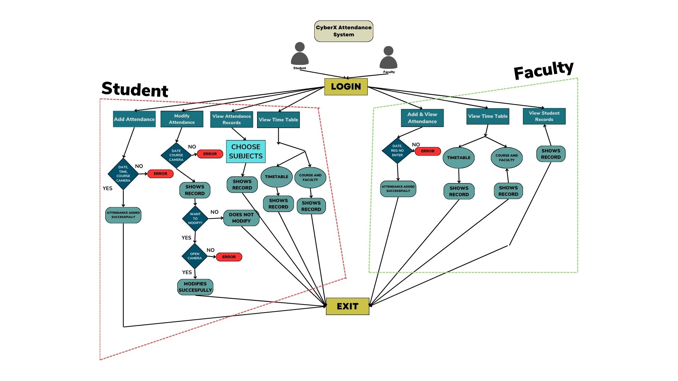

**SAMPLE OUTPUT:**

**MAIN FRAMES:**

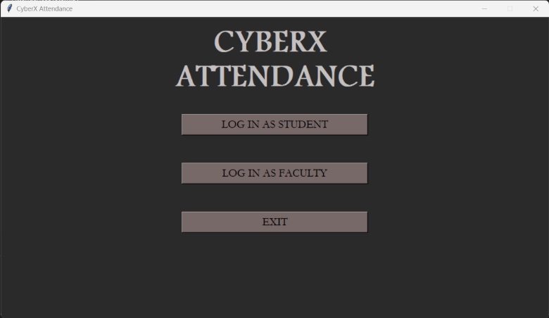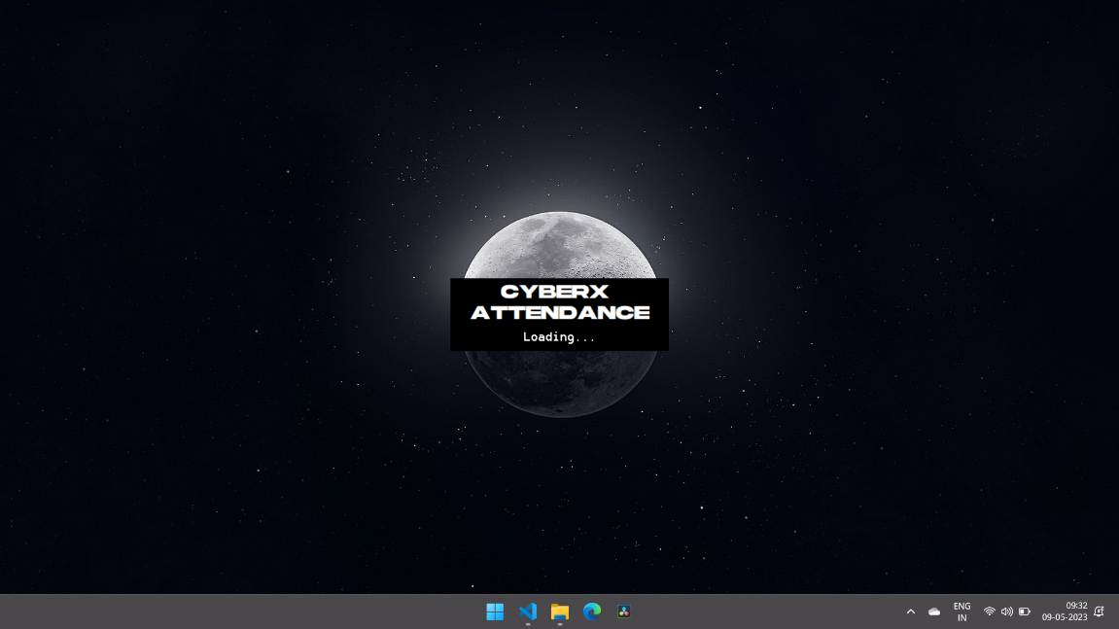

LOADING SCREEN

MAIN FRAME

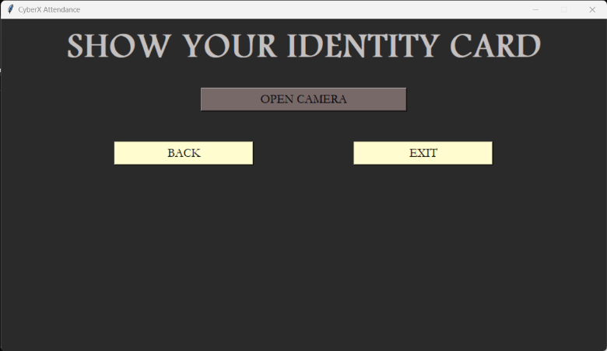

CAMERA FRAME

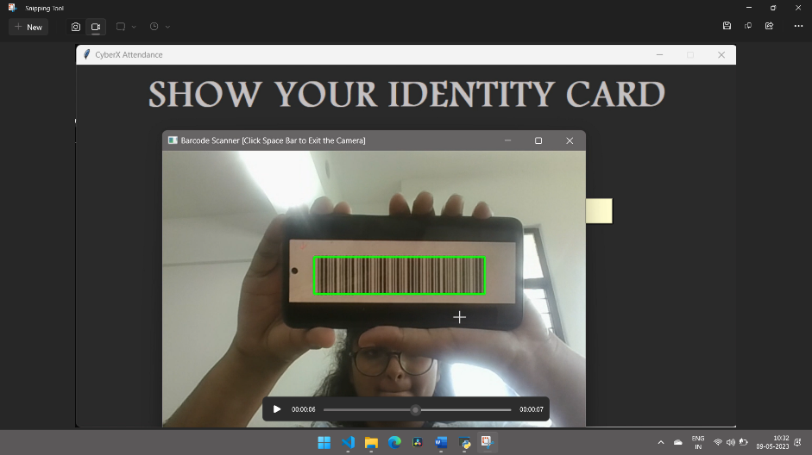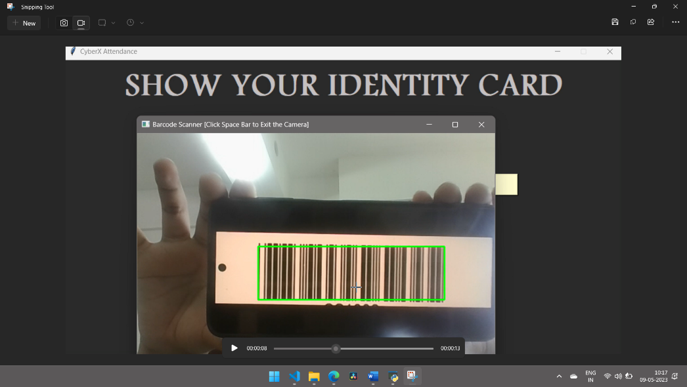

CAMERA FRAME - STUDENT

CAMERA FRAME - FACULTY

**FACULTY FRAME:**

**ADD AND VIEW ATTENDANCE:**

**MARKING PRESENT:** **MARKING ABSENT:**

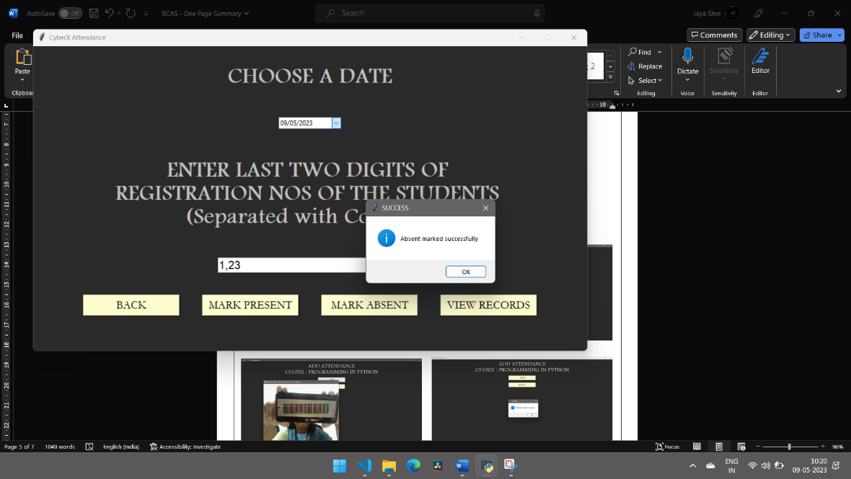

**VIEWING RECORDS:**

**VIEW TIMETABLE AND COURSES-FACULTY:**

**VIEW TIMETABLE:** **VIEW COURSES AND FACULTY:**

**VIEW STUDENT RECORDS:**

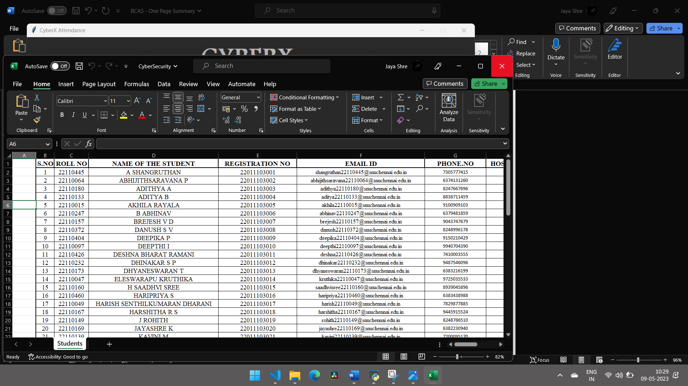

**STUDENT FRAME:**

**ADD ATTENDANCE:**

ADD FRAME

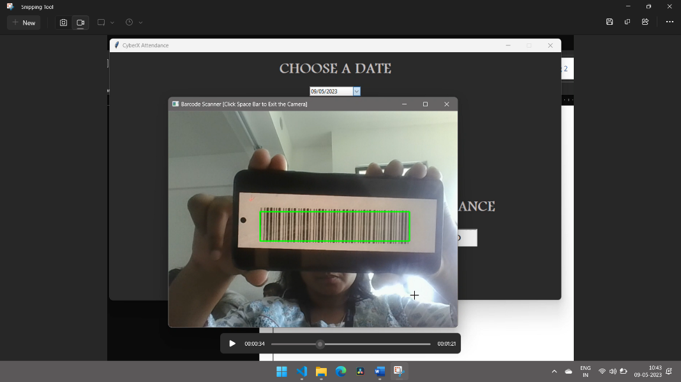

ADD FRAME - CAMERA

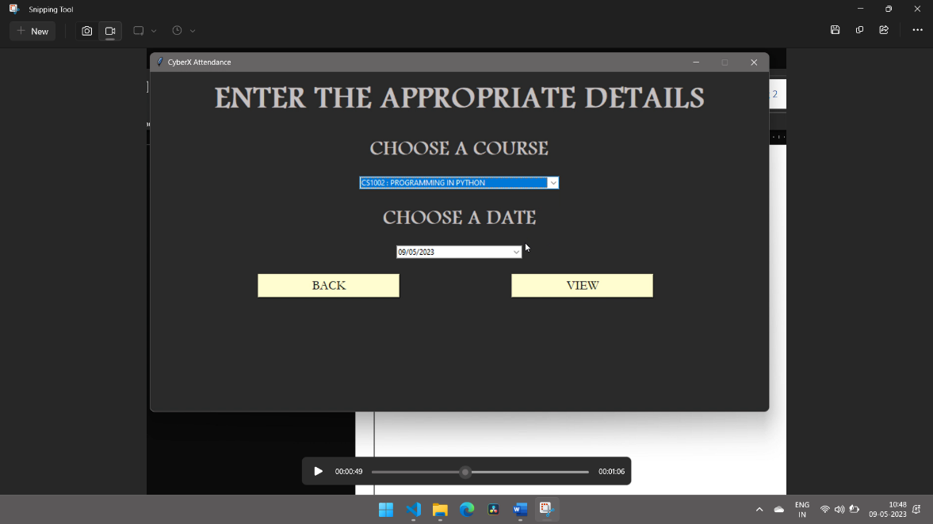**MODIFY ATTENDANCE:**

MODIFY FRAME

MODIFY FRAME - YES

MODIFY FRAME - AUTHENTICATE

MODIFY FRAME - CAMERA

MODIFY FRAME - MODIFIED

**VIEW ATTENDANCE RECORDS:**

EXCEL FILE

VIEW RECORD FRAME

**VIEW TIMETABLE:**

**VIEW TIMETABLE:** **VIEW COURSES AND FACULTY:**

**CONCLUSION:**

The Barcode Scanning based Attendance System is an efficient way to manage attendance records in a college setting. The system uses Python, OpenCV, and Excel to automate the attendance process, saving time and reducing errors. The system uses SVM Classifier to recognize barcodes and a dataset of barcode images to train the classifiers. The system uses various image processing techniques to improve the quality of barcode images before classification.